The Chris McCandless Obsession Problem

Every year, scores of Into the Wild fans tackle a dangerous river crossing to visit the last home of Alaska’s most famous adventure casualty. Why are so many people willing to risk injury, and even death, to pay homage to a controversial ascetic who perished so young?
By: Diana Saverin

Dec 18, 2013
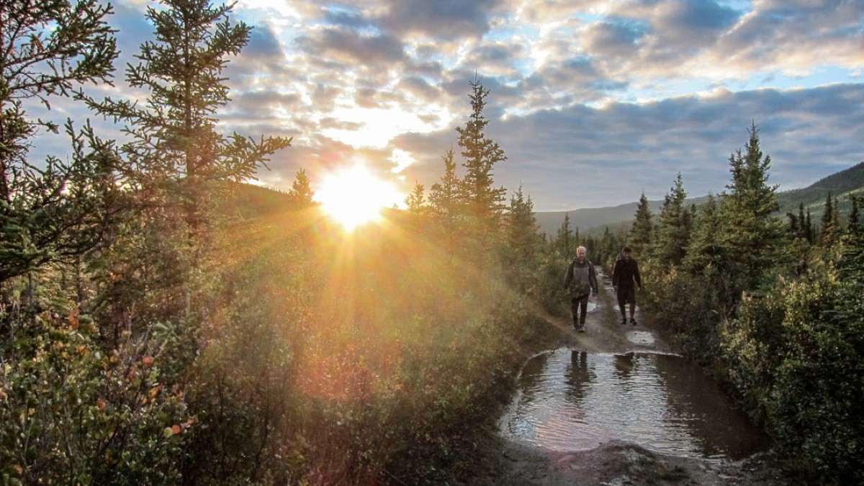

Jonathan and Claraso walking the Stampede Trail on their way to notify troopers that Seques and Shoup are stranded on the far side. Photo: Diana Saverin
On the isolated shore of the Savage River, in the backcountry of interior Alaska, there’s a small memorial to a deceased woman named Claire Ackermann. A pile of rocks sits on a metal plaque with an inscription that reads, in part: “To stay put is to exist; to travel is to live.”
Three years ago, Ackermann, 29, and her boyfriend, Etienne Gros, 27, tried to cross the Teklanika River, a couple of miles west from the Savage. They tied themselves to a rope that somebody had run from one bank to the other, to aid such attempts. The Teklanika is powerful in summertime, and about halfway across they lost their footing. The rope dipped into the water, and Ackermann and Gros, still tied on, were pulled under by its weight. Gros grabbed a knife, cut himself loose, and swam to shore. He waded back out to try and rescue Ackermann, but it was too late—she had already drowned. He cut her loose and swam with her body 300 yards downstream, where he dragged her to land on the river’s far shore. His attempts at CPR were useless.
Ackermann, who was from Switzerland, and Gros, a Frenchman, had been hiking the Stampede Trail, a route made famous by Christopher McCandless, who walked it in April 1992. Many people now know about McCandless and how the 24-year-old idealist bailed out of his middle-class suburban life, donated his $24,000 in savings to charity, and embarked on a two-year hitchhiking odyssey that led him to Alaska and the deserted Fairbanks City Transit bus number 142, which still sits, busted and rusting, 20 miles down the Stampede Trail. For 67 days, he ate mostly squirrel, ptarmigan, and porcupine, then he shaved his beard, packed his bag, and started walking back toward the highway. But a raging Teklanika prevented him from crossing, so he returned to the bus and hunkered down. More than a month later, a moose hunter found McCandless’s decomposed body in a sleeping bag inside the bus, where he had starved to death.
This tragic story was told by Jon Krakauer in the January 1993 issue of Outside and later in his bestselling 1997 book, Into the Wild. The book, and a 2007 film directed by Sean Penn, helped elevate the McCandless saga to the status of modern myth. And that, in turn, has given rise to a unique and curious phenomenon in Alaska: McCandless pilgrims, inspired by his story, who are determined to see the bus for themselves. Each year, scores of trekkers journey down the Stampede Trail to visit it. They camp at the bus for days, sometimes weeks, write essays in the various logbooks stowed inside, and ponder the impact that McCandless’s antimaterialist ethic, free-spirited travels, and time in the Alaskan wild has had on how they perceive the world.
UNFORTUNATELY, A LOT OF THESE people get into trouble, and almost always because of the Teklanika. In a recent story, writer Eva Holland reported that, in the summer of 2013 alone, a dozen people had been “lost, hurt or stranded by the rising river” on the Stampede Trail and had required rescue. When I was in the area in September, I heard similar numbers from the local authorities who run those operations. I also witnessed, and occasionally became involved in, some of the rescues.
In September, five employees of the Grand, a hotel near the entrance to Denali National Park, had been walking to the bus as a way to pass two days they had off. The cool weather often makes autumn a safer time for the hike, but a string of rainy days had swollen the Teklanika to flood stage. Two hikers, Matthew Grigg and Scott Wilkerson, crossed first, making it to the far shore. Then they watched as the other three slipped into the cold, gray water.
Elizabeth Kubik, the only woman in the group, swam to the far bank and reached for a willow branch, but it was dead and came out of the ground when she grabbed it. She reached for another branch and was able to secure a grip. Wilkerson lifted her and her pack out of the water before giving a hand to another of the swimmers, Jake Zyrek, who was also clutching a branch. When Zyrek made it to land, his lips were purple; he was shaking so violently he could hardly speak.
One last hiker, Rick Johnson, remained in the water, unable to get out. He was the farthest from either bank when he lost his footing and fell into the water, making his swim more arduous. Grigg chased him downstream, trying to keep one eye on his bobbing head, but because the bank rises into bluffs and cliffs, he sometimes couldn’t tell where Johnson was. A hunter riding an ATV on the far shore shouted over the rush of the river, directing Grigg to Johnson. Johnson stayed in the water, which lingers at temperatures just above freezing, for 15 minutes. Grigg was finally able to pull him out of the current just before he hit a stretch of Class V rapids.
I walked down the trail the next day, running into two bearded Texans who were heading back to the highway. They told me that five people were stuck on the other side of the river and that they were on their way to notify troopers. When I arrived at the river, I saw the stranded hikers, clad in rain jackets and beanies, napping on the ground. They shouted that they had been there for a day and a half and that help was on the way. I asked if it was worth it, and they shouted in unison, “No!”
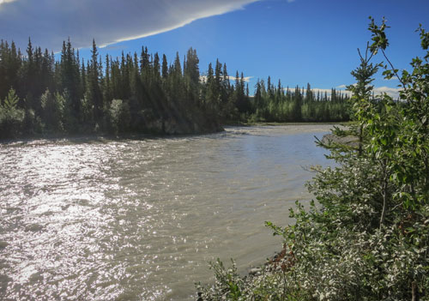
Pilgrims must negotiate a dangerous river crossing to reach the bus.
Photo: Diana Saverin
I dropped my pack and walked along the river’s edge, meandering between gravel bars and yellowing willows as the low sun gilded the water. After a couple of miles, I turned back toward where the trail hits the river. On the bus side, I spotted two moose hunters driving Argos, six-wheeled amphibious vehicles. I ran down the rocky bank, waving my arms and shouting, until they stopped and got out. I yelled that people were stuck on their side of the river, unable to cross back. The group of five hikers eventually found the Argos drivers, crossed the river in the vehicles, and headed back to town that night.
Unaware of the impromptu rescue, two troopers and two firefighters arrived on ATVs the next morning, squinting across the bank, looking for hikers in need of help. When I told them what had happened, they rolled their eyes. They pulled out crackers and meat sticks as they talked about the trail, each giving his suggestion for what to do with the bus: lift it by helicopter, place it on the highway side of the river, or put it in the national park and make it “their problem.”
The troopers told me that 75 percent of all of the rescues they perform in the area happen on the Stampede Trail. “Obviously, there’s something that draws these people out here,” one of the troopers, who asked not to be named, told me. “It’s some kind of internal thing within them that makes them go out to that bus. I don’t know what it is. I don’t understand. What would possess a person to follow in the tracks of someone who died because he was unprepared?”
I WENT TO ALASKA FOR the first time in the summer of 2011, on a grant to report and write radio stories in a small town in southeast Alaska. At summer’s end, I went farther north, spending an extra month and a half with my traveling partner, Jonathan, both of us living out of a 1993 Jeep Cherokee we nicknamed Muskeg, which had dented armor, a cracked windshield, and a missing tailgate handle. Jonathan and I drove 3,500 miles along seven of interior Alaska’s highways, reporting stories for Alaska Public Radio along the way.
It was Jonathan who first suggested we do a story about the McCandless seekers. The phenomenon is well-known in Alaska—a source of enduring controversy. Every summer, newspapers in Anchorage and Fairbanks publish reports about search-and-rescue episodes on the trail, which invariably prompt online catcalls from Alaskans, who tend to dismiss McCandless as a greenhorn who had no business in the northern wilderness.
Jonathan and I put the idea on our story list, and as we traveled around the state, we read Into the Wild to each other over the clatter of Muskeg’s engine. We soon felt the story’s pull. I was 20, Jonathan was 22, and McCandless’s uninhibited adventures spoke to both of us.
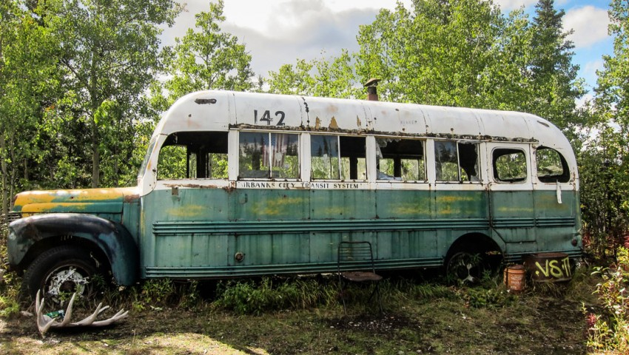
Mecca for McCandless fans: Bus 142 in 2011. Photo: Diana Saverin
One August afternoon that summer, we drove to Stampede Road, left Muskeg where the pavement turns to dirt, and started walking toward the bus. A few miles in, we arrived at the Savage River, the first major waterway between the trailhead and Bus 142, and searched its shore for a good place to cross. A lanky French hiker, who turned out to be Etienne Gros, came bounding out of the woods. His lethal incident on the Teklanika with Ackermann had happened the year before; this year, he said, he had hoped to lead her sister and mother down the trail to show them where Claire had died. But the Savage’s heaving water was too strong for them to cross, so they turned back. Gros escorted the Ackermanns to a motel in town and then returned with a friend to build the memorial.
As we stood next to the gushing gray water, Gros told us about the two months he and Ackermann had spent traveling in Alaska and Canada before their lethal encounter with the Teklanika. They’d met up in Vancouver—the beginning of what was supposed to be a two-year journey around the world. They hadn’t planned to hike to the bus originally, but they’d gone to Denali National Park the day before, where they met two French hikers who told them it was possible to hike to the bus. They changed their plans and decided to go. It was the end of summer, and they thought they might see the aurora borealis. Gros told us how beautiful the weather had been and how beautiful they found the trail. There’s a photograph of them on the trail, taken not long before the river crossing, in which they’re both laughing—the last picture taken of Ackermann before her death. As Gros recalled the incident on the river, he was quick to defend her, emphasizing how experienced she was as a scuba diver and mountaineer.
Jonathan and I said our goodbyes, and a couple of hours later we arrived at the Teklanika. We followed the bank upriver to a spot where the water splits into three braids. We unloaded a pack raft, and Jonathan practiced his paddling in an eddy. Gaining confidence, we piled in and ferried our bags and ourselves across the swift, silt-filled water, pausing on gravel bars along the way. On the other side, looking for a place to set up camp, we noticed two tents and a hammock nestled among black spruce. Three dazed backpackers emerged. One of them, Phil Shoup, an older man from Tennessee, started yelling, “Glory! Hallelujah! They’re heaven sent!”
One of the others, Dan Sans Clarasó, a young backpacker from Spain, crawled out of his hammock. It had been Clarasó’s idea to hike to the bus. He’d convinced his two traveling friends, Shoup and Lleques Seques, another backpacker from Spain, to come with him. They made it to the bus, crossing the Teklanika when it was knee-deep. But they had returned to find it surging over its banks.
Crossing back seemed potentially fatal, so they’d waited for several days. They watched the river continue to swell with late-summer rains, sleeping much of the day to pass the time. Eventually, they started running out of food. No one knew they were out there. They’d been stuck for days by the time we arrived.
We attempted to ferry them back across the river, but Shoup, a large man, weighed 100 pounds more than the raft’s weight limit. When he and Jonathan got in, the raft’s edges sagged beneath the waterline, and it started filling up with water. Shoup walked back to his campsite that night in wet clothes, defeated. Jonathan and I ran back to town the next day with Clarasó—Lleques stayed behind with Shoup—to notify the authorities. Soon a helicopter was on its way to rescue them.
I RETURNED TO ALASKA LAST summer on a journalism grant to research the McCandless pilgrims more thoroughly. I lived in a one-room cabin without water or electricity, on an 80-acre homestead a couple of miles north of Stampede Road, bouncing between the neighboring worlds of pilgrims and locals.
The Magic Bus, as McCandless called it in a short note in the back of his field guide to plants, was dragged into the backcountry north of Denali National Park in the 1960s by a D-9 Caterpillar. Fitted with bunks and a barrel stove, Fairbanks 142 and two other buses housed workers who were building a road out to an antimony mine on Stampede Creek. That project was eventually halted, and the other buses were hauled back to town. But one of the axles on Bus 142 had broken, so it was left in the bush.
These days the trail is an overgrown dirt road, punctuated by beaver ponds, creeks, and two glacial rivers, the Savage and the Teklanika. There has been some push from Claire Ackermann’s family, along with Chris McCandless’s younger sister, Carine, and a few others, to build a footbridge across the Teklanika for safer crossings, but so far those plans haven’t gone anywhere, and the river remains a danger to those attempting to ford it.
Stories of trouble are in abundant supply. One hiker I met, from South Korea, told me he had been swept 500 feet downstream while trying to cross. He was alone and lost most of his gear, including the camera he used to document his yearlong journey around the world—inspired by Into the Wild. Another solo hiker, from Australia, capsized trying to paddle across the river in a pack raft. He dislocated his shoulder but managed to swim to the other side, where he used the swift current to push the bone back into its socket, clutching willow branches on the river’s bank to steady his body in the frigid water.
Ten miles past the Teklanika, the trail opens into a clearing where the bus sits at the edge of the woods, its old tires sinking into the ground. Some hikers hoot and holler at the sight of it when they arrive. Others pause, open-mouthed, and stare.
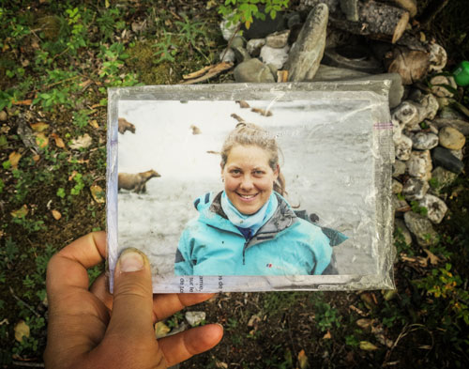
A ziplock bag with a letter and photograph of Claire Ackermann at the memorial to the 29-year-old on the banks of the Savage River. Photo: Diana Saverin
Once wild, the site now looks worn with use. Charred fire rings, bullet cartridges, and soda cans are scattered on the surrounding grass. Trash—an empty marshmallow bag here, half-burned toilet paper there—is littered about, though much is consolidated into old oil drums and garbage bags that overflow with wine bottles, ravioli cans, and spent bags of dehydrated backpacking meals.
Most windows on the bus are cracked or missing, covered by a few tarps that rattle in the breeze. Shards of broken glass are sprinkled on the ground. The bus’s green-and-white paint job is fading back to school-bus yellow in places where spidering webs of rust haven’t oxidized it to brown. Two parallel indentations in the frame mark a spot where a truck seems to have rammed the bus, perhaps in an attempt to knock it over. The “142” is freckled with bullet holes.
The door inside remains stiffly ajar, creaking when budged. Hay covers the floor. At the far end is the bed where McCandless’s body was found. It’s now covered with a sheet and a brown quilt. Behind folds of tarp, there’s a plaque that Billie and Walt McCandless placed for their son in 1993, “commending his soul to the world.” A pale blue suitcase they left rests atop a broken set of drawers across from the barrel stove.
Rope, bug spray, newspapers, blankets, Jack London and Leo Tolstoy paperback collections, emergency food, an inhaler, binoculars, a side-view mirror, candles, a handmade poster that reads “Happiness Road Only Real When Shared,” and an Altoids tin are scattered in and around the drawers. The tin contains a message, written in Sharpie, addressed to Chris: “All I could think of to give you that would really be a part of me.” Graffiti covers almost every square inch of the interior frame with names, dates, and a few quotes: “Live the life you always imagined,” “Two roads diverged in the wood, and I chose the path less traveled,” “Get busy living or get busy dying.”
Most of the writing happens in the logbook, though. When Carine McCandless visited the bus in August 2007, she left a notebook with a quote on the cover: “There is no way to happiness; happiness is the way.” She wrote that she hoped her brother’s philosophy of simplicity and honesty would one day be more widespread.
The notebook now contains hundreds of entries. One begins, “Dear fellow dreamers.” Another calls the bus “the wildest hostel of all.” One man wrote that he walked here from Minnesota. A woman wrote that she’d been “a bitch” to her boyfriend right before he fell into the Teklanika on their way to visit the bus. She signed off asking for good luck because it was raining.
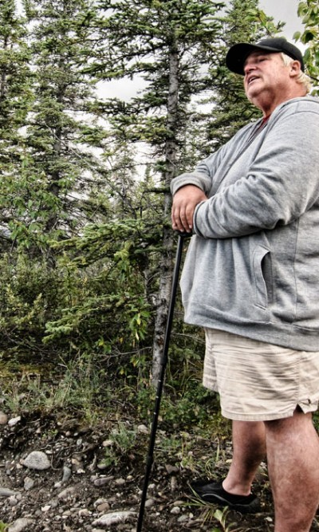
Pilgrim Phil Shoup on the banks of the Teklanika River in 2011.
Photo: Diana Saverin
Enamored with the spot, many write that they could see why McCandless stayed. One man described his plans to call his parents for the first time in eight years, and another said he would propose to his significant other when he returned from the trail. Many say that McCandless’s story is not about a man who died but about someone who truly lived. Some express gratitude to him, “for guiding our hearts to find our own paths,” “for giving people hope,” and for having the “guts and glory and faith to carry out his dreams.”
MANY ALASKANS, OF COURSE, don’t feel any reverence for McCandless at all. The debate about his worth is often harsh; locals like to float theories about his death wish, his alleged schizophrenia, and his outright foolishness.
The intensity of the debate was rekindled this past September, when Jon Krakauer wrote a story for The New Yorker’s website that revised his theory about how McCandless died. Krakauer argued that it happened because of a neurotoxin called ODAP, which is found in a plant that McCandless was eating and can cause lathyrism, a condition that leads to paralysis. Because the plant is widely considered edible, Krakauer declared that this finding confirms his long-held belief that McCandless wasn’t “as clueless and incompetent as his detractors have made him out to be.”
Plenty of commentary ensued, and plenty of it charged with controversy. “Raised by a game guide in AK my family has ‘respect’ for the land that is different than city kids from ‘outside,’” wrote “kvalvik” in a comment on Krakauer’s article. “Respect for the land comes to mean it will kill you as fast as a slow rabbit in front of a fast fox.”
Few have been as scathingly critical of McCandless’s sympathizers as Craig Medred, an Alaskan who has written numerous pieces about him over the years. In the Alaska Dispatch this fall, Medred, responding to Krakauer’s article, noted the irony of “self-involved urban Americans, people more detached from nature than any society of humans in history, worshipping the noble, suicidal narcissist, the bum, thief and poacher Chris McCandless.”
The pilgrims often encounter similar disdain. I know of beer-toting locals on ATVs who falsely warned three hikers from Phoenix that a “forest fire” was burning between the Teklanika and the bus, urging them to turn back. A pair of hikers I met told me about their experience buying the film’s soundtrack at the Anchorage Barnes and Noble, where one man told them that the bus had been removed. When they went to the Backcountry Information Center at Denali National Park to ask questions about the hike, a ranger told them it wasn’t her job to tell them where the bus was, and that if they didn’t know, they had no business being out there. She said she would end up pulling their bodies out of the river.
Much of the polarization surrounding McCandless stems from a divide in people’s beliefs about what justifies risk-taking in the backcountry. In Alaska, it’s generally considered acceptable to invite risk while making a living on the land—fishing, hunting, logging, mushing, trapping. It is less acceptable to take chances in search of a more philosophical way of life.
The trooper I had spoken with about the rescue of the Grand Hotel employees complained to me that people heading into the wilderness for purposes of self-discovery can be driven in a way that makes them do stupid things, such as disregarding the weather.
“It’s different if you have a trapline and that’s how you make your living,” he said. “Those guys live out there. They have to go out when it’s 40 or 50 below.”
Part of what infuriates many about McCandless was the fact that he intentionally made his trip more dangerous than it had to be—bringing only rice for food, leaving behind a topographical map and compass. He sought a wilderness like the one Wallace Stegner described as “the challenge against which our character as a people was formed.” Most folks around Healy, the town four miles south of the Stampede Road turnoff, prefer to wander the woods by all-terrain vehicles. It’s faster.
The topic of McCandless and the pilgrims came up at a potluck I attended in September. When the name came up, the people in the room, who had so recently been jolly over the halibut and beer, became angry, their voices rising as many shouted and swore over each other.
“Why don’t they just read A Walk in the Woods?” said Andrew Pace, a flannel-clad dog musher who lives on Stampede Road and works in Denali National Park.
The guests rattled off names of Alaskans who had homesteaded remote areas of the state. “There are so many success stories,” Pace said. “It just makes me mad that one about a failure is so famous.”
FOR A STORY ABOUT A young man who wanted to spend more time outside, many of its most obsessive fans spend a great deal of time inside and online. Numerous forums and Facebook pages contain thousands of posts and dozens of full-length essays about McCandless. There is the Christopher McCandless forum, the Stampede Trail information site and various Into the Wild Facebook pages. Followers number in the millions.
Fans have asked each other whether to stay put or travel, whether the scene in the movie in which Emile Hirsch looks at the camera is symbolic or not, whether the Internet would have made McCandless more prepared or more angry. One asked how to get the same glasses Hirsch wore in the movie. Some share pictures of their Bus 142 tattoos, their homemade pendants, and their Lego-and-duct-tape models.
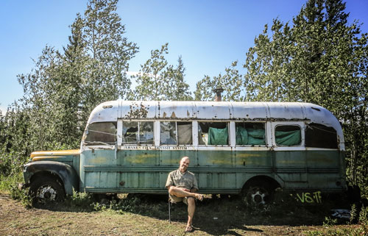
Steve Salmon re-enacting the iconic photograph of Chris McCandless at Bus 142. Photo: Diana Saverin
Steve Salmon, a 40-year-old from New Jersey with a graying goatee and stocky gait, was so involved with the forums at one time that he said it was like having a full-time job. We walked to the bus together this August. Salmon had made the Lego-and-duct-tape models, and he’d purchased back issues of The New Yorker and People magazines on eBay with the original articles about McCandless’s death. Before we hit the trail and lost service, he texted from the side of Stampede Road, flashing his iPhone at me to show me a new text message.
“That’s my friend Carine,” he said, smiling.
Another fan, Mike Kramer, 41, has lived in Kentucky, mostly mowing lawns, for the past eight years. The most recent three of those years he spent living in a tent. He calls himself homeless by choice, and says that if he wrote a book, he would call it 365 Days on a Hill Next to Walmart.
A few years ago, Kramer rented the movie Into the Wild never having heard of it. The next day he read the book. The day after that, he bought a ticket to Alaska to go see the bus. Before leaving, he got in touch with Erik Halfacre, asking for advice about the trail. He had no experience in the backcountry, but like many others, he decided it required more determination than expertise.
Halfacre, who lives in Anchorage, created a website devoted to hiking the Stampede Trail. Pilgrims use it to coordinate group hikes to the bus and exchange advice about the trip. When Carine needed a hiker to bring another logbook to the bus, Halfacre put her in touch with Kramer. She called him one night and introduced herself, leaving Kramer stupefied. He describes her as the closest thing to a celebrity he knows.
To date, Kramer has been to the bus three times. His second trip was in March 2011. He spent 16 days on the trail. The temperature reached 30-below, and he suffered frostbite on his thumb. Instead of melting snow for water, he sprinkled Kool-Aid packets onto handfuls of snow and ate them frozen. He spent most of his time collecting wood to keep the fire in the bus’s barrel stove going. The troopers checked on him twice. When they asked if he had enough gear, he said he had an extra pair of blue jeans. During one of these visits, a trooper told Kramer he didn’t want to die carrying Kramer’s dead body out.
This fall, I met Carine McCandless in New York City, where she was visiting from her Virginia home to give a lecture at Riverdale Country School in the Bronx. She has long brown hair and a wide smile. She wore jeans and a red top, and spoke with a full and kind voice.
Carine, 42, estimates that she still receives 30 messages a day from people who’ve been affected by her brother’s story. She answers each e-mail personally. She writes at the desk Chris used in high school and sometimes carries a rock she picked up on her visit to the bus in her jeans pocket. Many high schools have incorporated Into the Wild into their curricula, and she sometimes visits the schools to give talks.
A now iconic photo of Fairbanks 142 serves as the header for her website, a picture of her standing between Jon Krakauer and Sean Penn at the Los Angeles film premiere is on the home page, and a note declaring her determination “to continue to be his voice and carry on his message” is also on the site.
“I think Chris would find it remarkable that people find him so remarkable,” she told me, adding that Chris was genuinely mystified as to why more people didn’t simply take off like he did.
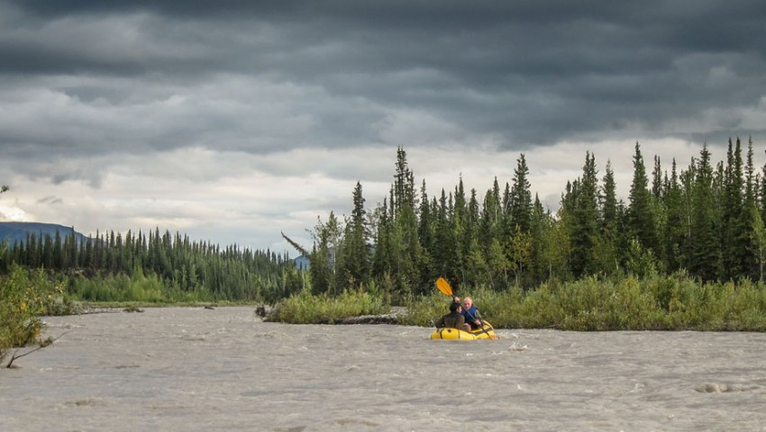
Two trekkers ferrying across the Teklanika River in a packraft.
Photo: Diana Saverin
Since his death, McCandless’s family has been actively involved with the community of seekers. In 2011, his parents, Billie and Walt, published Back to the Wild: The Photographs and Writings of Christopher McCandless. The 241-page book contains photos he took during his travels, from Detrital Wash, Arizona, to South Dakota to Bus 142, with captions written by Walt.
Carine created a public Facebook page called “Carine McCandless Into the Wild.” She wrote a letter on it, detailing her feeling of responsibility to speak for Chris, since he could no longer speak for himself. She described some of the domestic violence she and Chris experienced as children, writing about their father’s “gin-induced rages,” in which he told them he was God. She criticized her parents’ publication of Back to the Wild, calling it an attempt to “take advantage of vague portrayals of our history with their efforts to create a new one.” She described her intention with the page as offering an emphatically true connection to Chris.
And while she still lives in the same town as her parents, she said she sees them so little that one of her daughters wouldn’t be able to recognize them if she saw them in the street.
A link to this message was posted on the Facebook page “Back to the Wild–the new book of Christopher McCandless.” Joseph Moss, who was the photo editor and designer for the project, commented and accused Carine of airing her family’s dirty laundry to the public. He said the story is not just for the McCandless family; after Into the Wild, it became a story “for all of us.” Many responded, including Carine. She wrote that her parents “continue to bully him in his death.” She asked Moss to come to her house to see unpublished letters from her brother if he didn’t believe her accounts of the abuse they and their other siblings experienced.
Back to the Wild came up when Carine was fielding questions from starry-eyed students after her Riverdale lecture. Afterward, I asked what upset her about the new book.
“They say that they’re not lying, but when you’re presenting our family as some perfect Christian family, it’s not the full picture,” she said. “The first sentence on the e-book is something about how we can only imagine why a young man would set off and sever ties with his family and friends. But they knew why he left.”
Carine is coming out with a memoir, The Wild Truth, about her brother and family next year, in what she called an attempt to “tell the whole story.” In a description of the book, she wrote that she and her half-siblings have come together since Chris’s death and found absolution, as she believes Chris found in the wild before he died.
At the end of her Riverdale lecture, she showed a picture of the note that McCandless left when he died, writing in block letters that he had had a happy life and thanked the Lord. She then asked the students how they wanted to feel in their final days.
“It’s tragic my brother died young. But because of the trails he had chosen, he died at peace. Isn’t that the best that any of us can hope for?”
Many of the students thought so. A few have started fantasizing about taking trips to Alaska to visit the bus. One senior asked me if there was any program that could take you. Another told me she was planning a trip for the first week of March.
DURING MY TIME ON the trail, I met a pair of French cyclists, three middle-aged engineers from Arizona, three Spanish travelers (on their way to work on marijuana farms in Washington), an Italian trekker, and a backpacker from Georgia who travels, train hops included, with a kitten perched on his shoulder. One fan from Minnesota flew out to Alaska, walked the 40 miles round-trip in one day, then drove straight back to the airport.
Jedidiah White, 25, from Missouri, read Into the Wild shortly after breaking up with a longtime girlfriend and deciding not to go to medical school. He wasn’t sure where to turn, and the story provided a direction. He began planning a 22-day trip floating the Teklanika from inside Denali National Park to visit the bus. He had little experience outdoors, and he set out for the bus schlepping 70 pounds of gear, including an iron skillet, a knife sharpener, and two rafts. On the second day of his trip, he flipped his boat in some rapids. His gear got wet, his raft tore, and he had to walk the rest of the way to the bus. But the experience “opened the gate,” he told me. Before the trip, he wanted to be a doctor and make a lot of money; now he wants to open a winery and spend more time outside. He’s been to the bus once more since, and he’s planning a six-week trip in the Stampede Corridor next summer.
Darren Storsley, 39, from Vancouver, assigns Into the Wild every year to his high school psychology class. He says it’s the best textbook he knows, and he confesses that he spent the better part of the time during his visit to the bus weeping.
A couple of weeks before walking the trail this past summer, Storsley picked up a hitchhiker at a gas station near Talkeetna. The tall and lanky backpacker, Mark McMillan, took up temporary residence in the passenger seat of Storsley’s Chevy Blazer as they road-tripped around Alaska. When I met them on the trail, they introduced themselves as “soul brothers.” They had driven all the way up to Prudhoe Bay, jumped in the Arctic Ocean, and discovered that McCandless was a shared hero.
“Here’s someone who heard the sermon of the world and didn’t like it,” Storsley said of McCandless as he leaned against his backpack on the trail. “Here’s someone who preached for himself instead. Just imagine if we all did that.
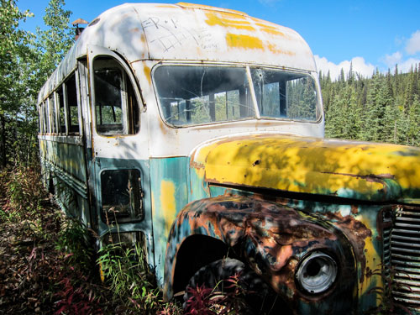
The rusting exterior of bus 142. See inside the bus. Photo: Diana Saverin
“I’m jealous,” Storsley went on. “He was braver than I am. I think I live according to my own values, but I’m still in society. I still have a job, I still make money. I go to work ten months out of the year, and I play for the other two. I’m still in the box. I’m not strapped to it, but I’m still in it. And he had the courage to step away from it.”
McMillan sat against his backpack, munching M&M’s. He’s a McCandless look-alike—curly brown hair and a scruffy beard—but about a foot taller. He used to keep the Into the Wild movie open on his laptop, watching ten-minute segments of it before doing homework. He’s always loved spending time outside. As a kid, he memorized the names of birds found in Southern California, paid for a membership to the National Wildlife Federation by selling homemade bread out of a wagon, and eventually headed into the woods to backpack, mountain-bike, and climb alone.
During his graduation ceremony at Walla Walla University, in southeastern Washington, he sat with his family at a Thai restaurant and told them that, while he loved them very much, they might not hear from him for the next five years. His plan at the time was to spend the rest of the summer pack-rafting down a 400-mile river in the Brooks Range with an edible-plant book, a fishing pole, and 40 servings of freeze-dried broccoli.
McCandless’s story, he explained to me, had helped him see the possibility of a life in which adventure was the norm, not the exception. His recent release from college meant he was free to pursue such a life.
“The bus is where McCandless’s journey ended,” McMillan said, “and the rest of ours begins.” O
Diana Saverin is the founder of the travel and adventure blog These Fifty States. This is her first story for Outside.

